Lab 02

More Flowcharts

Lab Exercises | (2 hours)
You may not be able to finish all flowcharts during the lab time. You are advised to do the remaining questions at home for training. Keep the flowcharts that you have drawn, we will convert them into C++ programs in the coming tutorials.
You are encouraged to discuss about these problems in groups of 2 to 3 people.

- Write an algorithm and draw a flowchart to accept a number representing a reading of a thermostat in Celsius and display the result as its equivalent Fahrenheit.
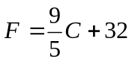
- Draw a flowchart to accept a number and display all the numbers from 0 to the number entered. Then modify the flowchart so that it displays only odd numbers.
e.g. Given 10, it should output: 1 3 5 7 9
- Draw a flowchart to accept a number and compute the sum of all the numbers below that number and above 0.
e.g. Given 5, output: 10 since 4+3+2+1 = 10
Given 9, output: 36 since 8+7+6+5+4+3+2+1 = 36
- Draw a flowchart to accept two numbers and display the modulus of the numbers without using the % operator.
e.g. Input 10 and 3 → 10 modulus 3 → Output: 1
Input 45 and 7 → 45 modulus 7 → Output: 3
- Draw a flowchart to accept a mark and display the grade given the following range of marks and associated grades.
Mark | Grade
80 – 100 | A
70 – 79 | B
50 – 69 | C
0 – 49 | F

- Draw a flowchart to accept a number and output its factorial.
e.g. Input 5 → 5! = 5x4x3x2x1 → Output: 120
Input 5 → 8! = 8x7x6x5x4x3x2x1 → Output: 40320
- The expansion of ln(1 + x) is given in the following formula:
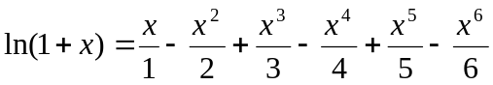
Draw a flowchart to solve this formula.
Take Home Exercises

- Draw a flowchart to display all the prime numbers below a given number.
e.g. Given 23 then the result should be 2 3 5 7 11 13 17 19
- Draw a flowchart for calculating the real roots of a quadratic equation using:
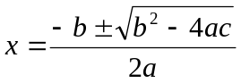
- Draw a flowchart to accept two numbers, and then output the result as the first number to the power of the second number:
e.g. Input 2 and 8 → 2x2x2x2x2x2x2x2 → Output: 256
e.g. Input 3 and 4 → 3x3x3x3 → Output: 81
- Draw a flowchart to calculate the value of sin(x):
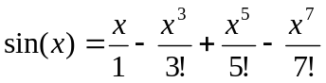
- A salesperson gets 5% percent commission on sales less than RM1000, 8% percent on sales in the range RM1000 through RM2000, and 10% percent on sales in excess of RM2000. Design a flowchart that reads an arbitrary number of sales made by a salesperson on given business day and then computes and prints the total number of sales, total amount of sales, and total commission earned by the salesperson. The input is assumed to come from the keyboard, and the input of sale amounts should terminate if the user of the program type 0.

